**UNLOCKING INSIGHTS INTO THE GLOBAL AIR TRANSPORTATION NETWORK**

1.Introduction

The worldwide air transportation network is represented by the database of International Air Transport Association. It is a critical infrastructure with high impact on mobility, trade and economy.

1.1. Overview:

The air transportation network is complex network which has the properties of small-world networks and scale-free networks

1.2.purpose:

Allows people from different countries to cross international boundaries and travel other countries for personal, business, medical and tourism purposes.

2. problem statement & Design thinking

2.1. Empathy map:

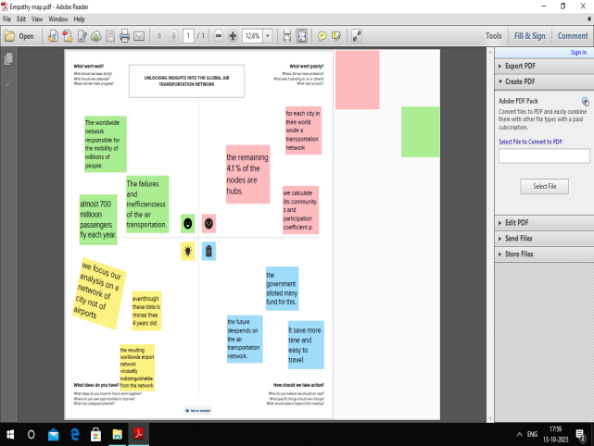

2.2. Ideation and Brainstorming Map:



3. Result

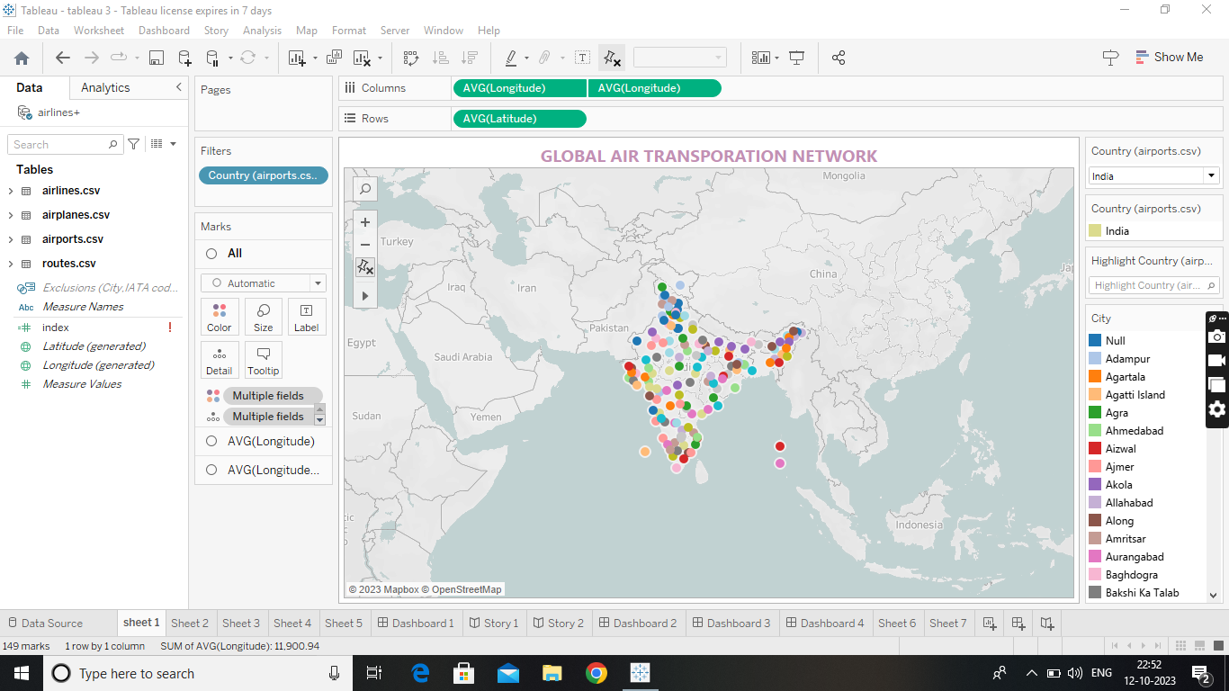



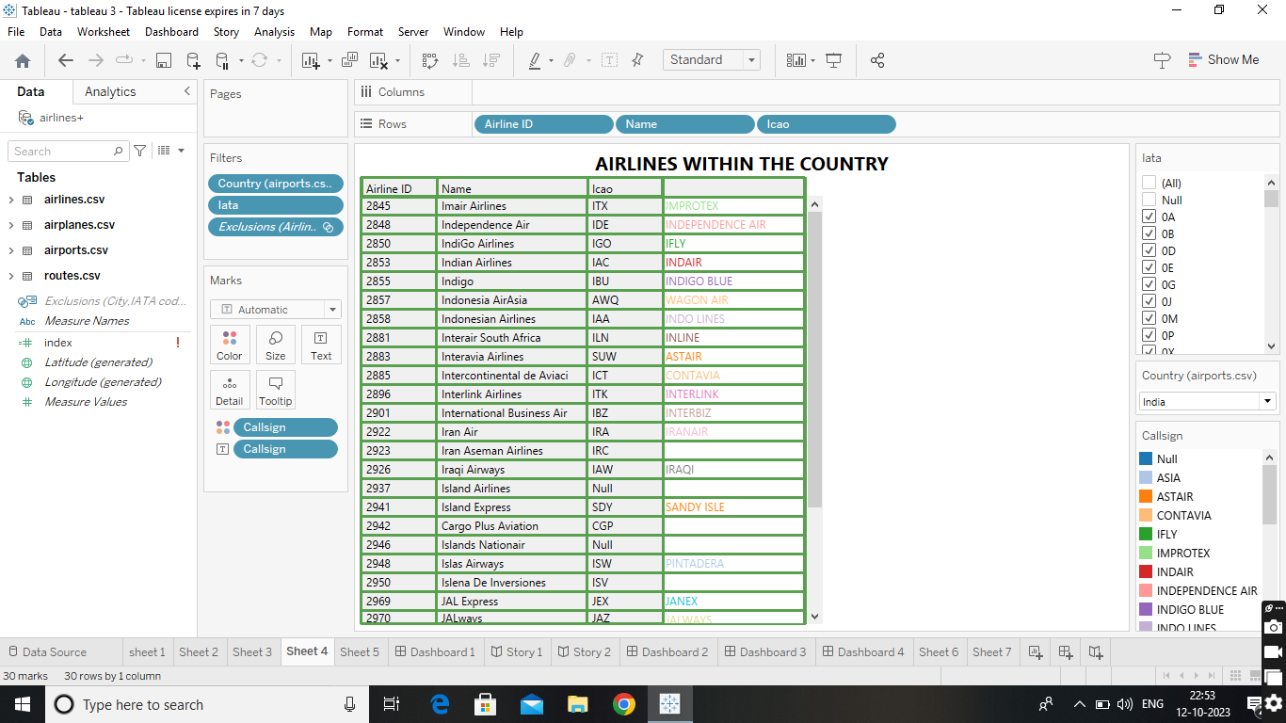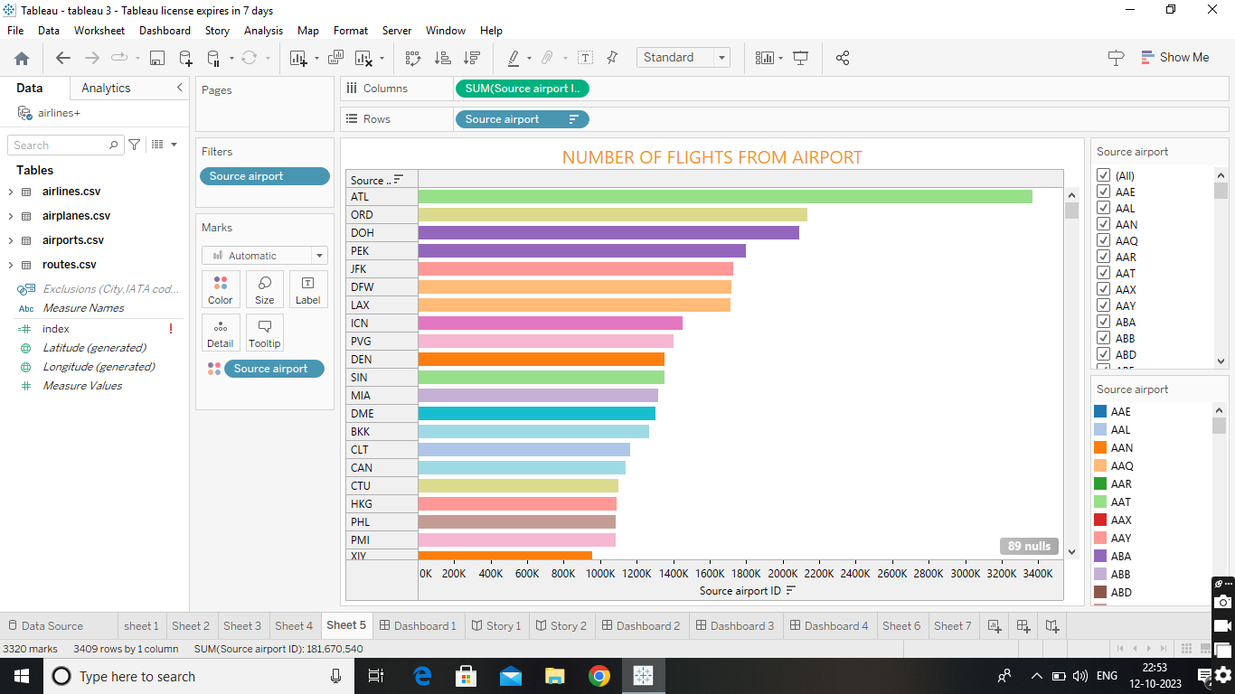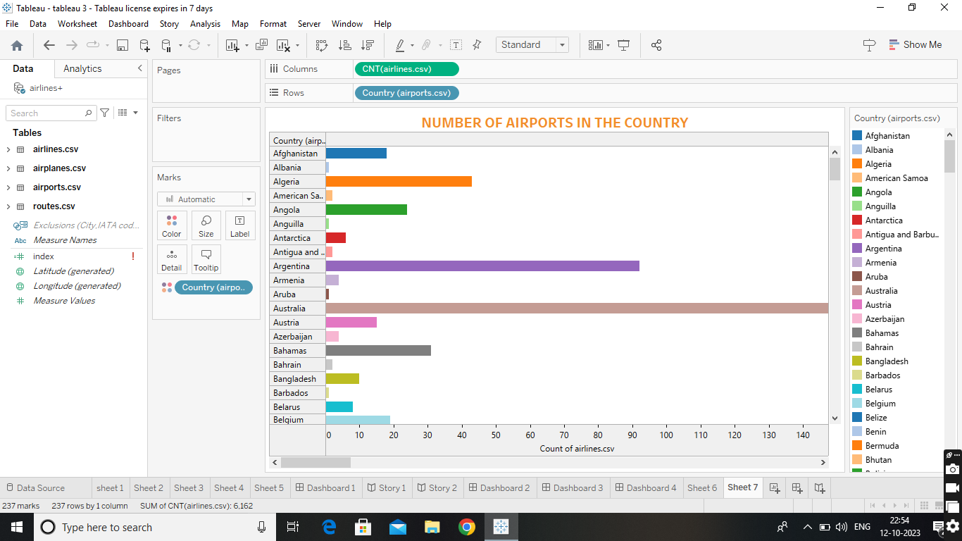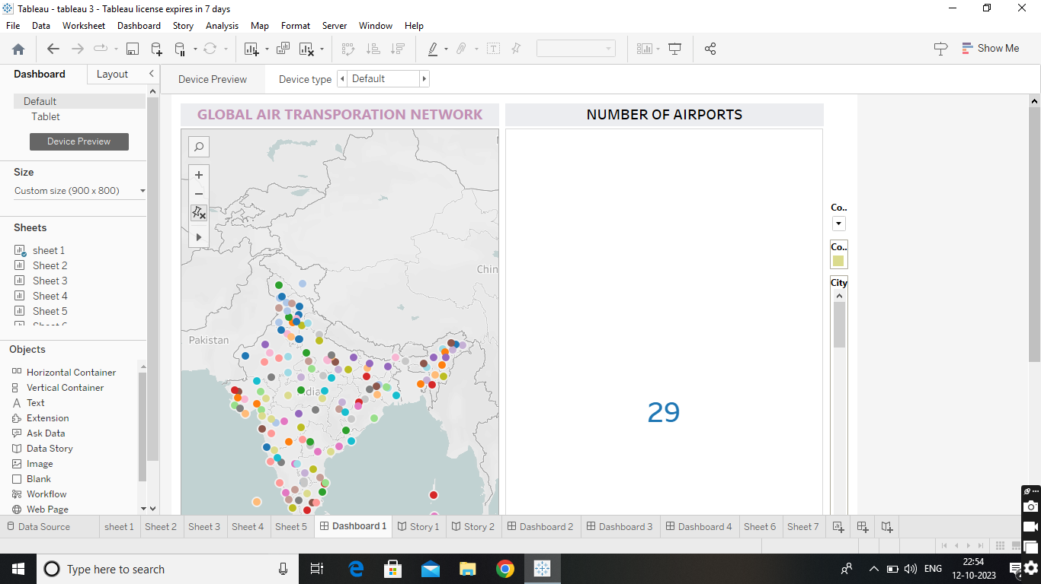

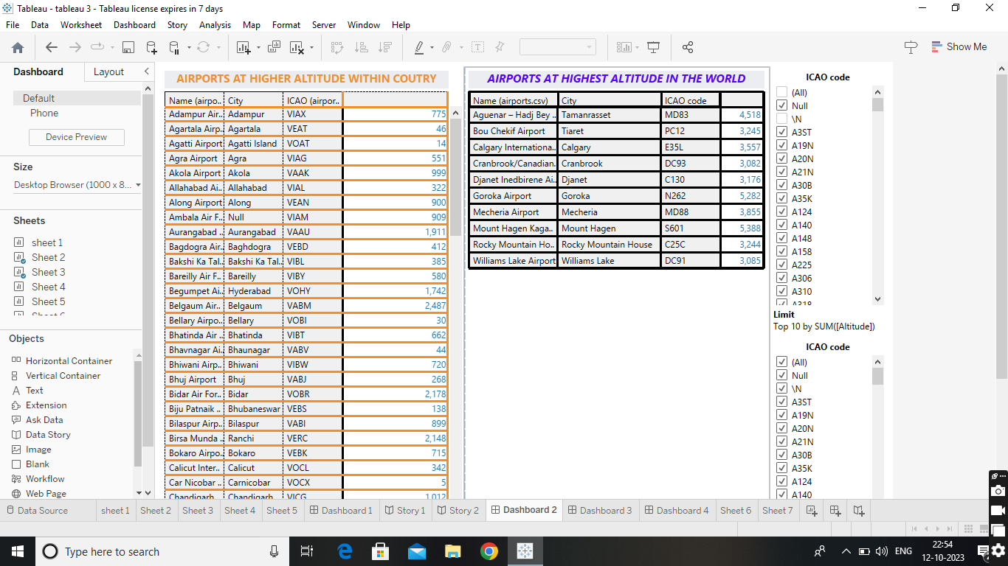



4. Advantages & disadvantages

Advantages: Global reach, reliable timelines, reduces inventory holding costs.

Disadvantages: Higher cost, Limited capacity, Restrictions on hazardous goods

5. Applications

Transport to market goods and products internationally and documents related to foreign trade operations

6. Conclusion

The international air transport association has been instruments in developing and improving the transport industry.

7. Future scope

Emerging technologies reshaping with robotics, artificial intelligence, the internet of things, unmanned aircraft systems and push for hybrid and electric airplanes.